**Activity 1 - Writing the Business Case and Documenting the Business Reporting Requirements**

**The Business Case:**

I would like to model a scenario from healthcare sector. Specifically I would like to design the data dynamics of a local clinic that has physicians issue prescriptions to patients. The prescriptions can be used to purchase drugs from the pharmacy for the patient. This business is a small business and operates using established healthcare best practices in the Northern Virginia region. There are a dozen doctors and attending staff, four data entry clerks and a dozen administration personnel. The business also employs a veteran DBA for checking and patching the Oracle 12c database that the clinic uses to keep track of patient details, prescriptions, drugs and pharmacy availability.

The normal work day for the clinic starts with a patient visit. Each patient is a clinic customer that is documented with his details in the PATIENT table. Once the patient’s details are entered or updated into the system a doctor with a suitable specialty is assigned to patient from the DOCTOR table. A doctor can attend to the patient and write one or more prescriptions. These prescriptions are stored in the PRESCRIPTION table. For each prescription there may be one or more drugs that are prescribed. Each drug is documented in the DRUG table using a drug code and price details. Each drug prescribed can be purchased and picked up at an associated pharmacy. The details about each pharmacy and whether or not it stocks the desired drugs are available in the PHARMACY table.

For the clinic the database serves as a critical technology that enables detailed documentation and tracking of patient needs. For each patient the associated drug stocks can be tailored and made available at the pharmacy by looking at prescription trends. For seasonal allergies for example a particular anti histamine drug can be made available at a local pharmacy when spring season starts in Virginia. Similarly based on patient visits the doctor staff can be tailored to provide specialty focused attention, assisting staff can be augmented as per specialty needs. The database table for PATIENT also has data regarding patient area code, owing to this detailed statistics can be gathered for epidemic disease outbreaks within an area zone. All this can be documented and processed via the Oracle database solution the business uses.

**Business Reporting Requirements:**

1. Must generate a report for the patients who were prescribed Albuterol this year.
2. Must generate a report for patients who were assigned to Psychiatry specialty this year.
3. Must generate a report for patients who were diagnosed with Schizophrenia and prescribed Clozapine this year.
4. Must generate a report for drugs that were available in Springfield pharmacy this year.
5. Must generate a report for drugs that were available in Fairfax pharmacy this year.
6. Must generate a report for doctors that were assigned to Cardiac specialty this year.

**Activity 2 – Business Rules, The E-R Model and Normalization for the Business**

**Business Rules:**

(0, 1)A DOCTOR writes one or more PRESCRIPTIONS. (1, N)

(1, N)One or more PRESCRIPTIONS may be written by a DOCTOR (0, 1)

(0, 1)A PATIENT may receive one or more PRESCRIPTIONS. (1, N)

(1, N)One or more PRESCRIPTIONS may be received by a PATIENT (0, 1)

(0, 1)A DRUG may appear in one or more PRESCRIPTIONS. (1, N)

(0, 1)A PRESCRIPTION may contain one or more DRUGS (0, N)

(0, 1)A PHARMACY may stock one or more DRUGS. (1, N)

(1, N)One or more DRUGS can be stocked by a PHARMACY (0, 1)

**ER Model:**

DOCTOR writes PRESCRIPTION

DRUG appears in PRESCRIPTION

PATIENT receives PRESCRIPTION

PHARMACY stocks DRUGS

**Sample Table Data:**

Table Name **DRUG:**

DRUG_CODE|| DRUG_NAME|| DRUG_PRICE

AA101            Clozapine              21.00

AA102             Albuterol              31.00

Table Name **DOCTOR:**

DOC_ID|| DOC_LNAME|| DOC_FNAME|| DOC_INITIAL||DOC_SPECIALTY

12345        Sanchez        John                J                    Psychiatry

56789         Chin               Ming              M                    Respiratory

Table Name **PATIENT:**

PAT_NUM||PAT_TITLE||PAT_LNAME||PAT_FNAME||PAT_INITIAL||PAT_DOB||PAT_AREACODE||PAT_PHONE

100           MR         LEWIS        RALPH            R      11 June 1982     703             111-2222

101             MS.         NASH         MELANIE       M     12 January 1989 702             222-1223

Table Name **PRESCRIPTION:**

PRES_ID||DOC_ID||PAT_NUM||DRUG_CODE||PRES_DOSAGE||PRES_DATE

001 212          100           AA101             2 TABLETS/HOUR   12 NOV 14

002 213           101          AA102             2 PUMPS AS NEEDED 12 NOV 14

Table Name **PHARMACY:**

DRUG_CODE|| PHARM_LOC|| PHARM_STOCK

AA101             VIRGINIA         YES, INSTOCK

AA102              WASHINGTON     YES, INSTOCK

**Normalization Diagram**

**3NF Normalization**

Table Name **DRUG**

DRUG_CODE|| DRUG_NAME|| DRUG PRICE

|  |  |  |
| --- | --- | --- |
| **DRUG_CODE** | DRUG_NAME | DRUG_PRICE |

Table Name **DOCTOR**

DOC_ID|| DOC_LNAME|| DOC_FNAME|| DOC_INITIAL||DOC_SPECIALTY

|  |  |  |  |  |
| --- | --- | --- | --- | --- |
| **DOC_ID** | DOC_LNAME | DOC_FNAME | DOC_INITIAL | DOC_SPECIALITY |

Table Name **PATIENT**

PAT_NUM||PAT_TITLE||PAT_LNAME||PAT_FNAME||PAT_INITIAL||PAT_DOB||PAT_AREACODE||PAT_PHONE

|  |  |  |  |  |  |  |  |
| --- | --- | --- | --- | --- | --- | --- | --- |
| **PAT_NUM** | PAT_TITLE | PAT_LNAME | PAT_FNAME | PAT_INITIAL | PAT_DOB | PAT_AREACODE | PAT_PHONE |

Table Name **PRESCRIPTION:**

DOC_ID||PAT_NUM||DRUG_CODE||PRES_DOSAGE||PRES_DATE

|  |  |  |  |  |
| --- | --- | --- | --- | --- |
| **DOC_ID** | PAT_NUM | DRUG_CODE | PRES_DOSAGE | PRES_DATE |

Table Name **PRESCRIPTION** with SURROGATE KEY of PRES_ID:

|  |  |  |  |  |  |
| --- | --- | --- | --- | --- | --- |
| **PRES_ID** | **DOC_ID** | PAT_NUM | DRUG_CODE | PRES_DOSAGE | PRES_DATE |

Table Name **PHARMACY**:

DRUG_CODE|| PHARM_LOC|| PHARM_STOCK

|  |  |  |
| --- | --- | --- |
| **DRUG_CODE** | **PHARM_LOC** | PHARM_STOCK |

**Activity 3 - Develop the Data Dictionary and Entity Participation Constraints**

Data Dictionary View in SQL Data Modeler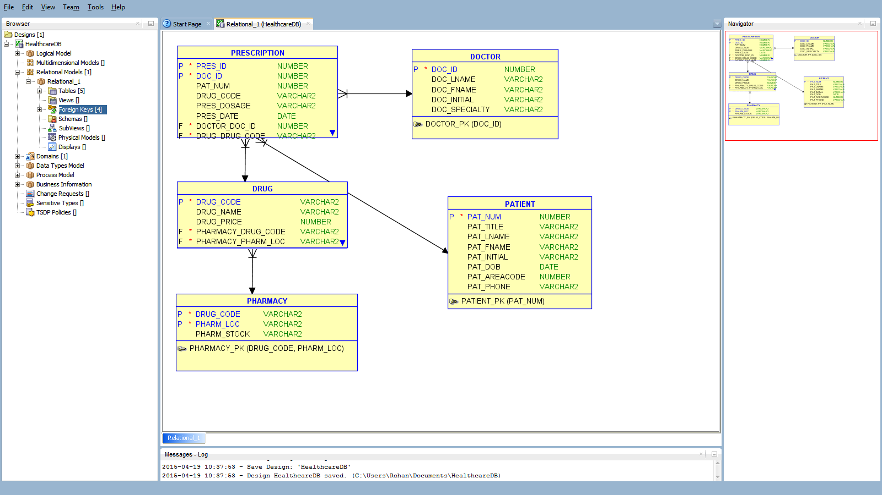

**Activity 4 - Write the SQL Data Definition Language script to physically implement the logical design**

DDL Generated via SQL Data Modeler

-- Generated by Oracle SQL Developer Data Modeler 4.0.3.853

-- at: 2015-04-19 10:56:31 EDT

-- site: Oracle Database 12c

-- type: Oracle Database 12c

CREATE TABLE DOCTOR

(

DOC_ID NUMBER NOT NULL ,

DOC_LNAME VARCHAR2 ,

DOC_FNAME VARCHAR2 ,

DOC_INITIAL VARCHAR2 ,

DOC_SPECIALTY VARCHAR2

) ;

ALTER TABLE DOCTOR ADD CONSTRAINT DOCTOR_PK PRIMARY KEY ( DOC_ID ) ;

CREATE TABLE DRUG

(

DRUG_CODE VARCHAR2 NOT NULL ,

DRUG_NAME VARCHAR2 ,

DRUG_PRICE NUMBER ,

PHARMACY_DRUG_CODE VARCHAR2 NOT NULL ,

PHARMACY_PHARM_LOC VARCHAR2 NOT NULL

) ;

ALTER TABLE DRUG ADD CONSTRAINT DRUG_PK PRIMARY KEY ( DRUG_CODE ) ;

CREATE TABLE PATIENT

(

PAT_NUM NUMBER NOT NULL ,

PAT_TITLE VARCHAR2 ,

PAT_LNAME VARCHAR2 ,

PAT_FNAME VARCHAR2 ,

PAT_INITIAL VARCHAR2 ,

PAT_DOB DATE ,

PAT_AREACODE NUMBER ,

PAT_PHONE VARCHAR2

) ;

ALTER TABLE PATIENT ADD CONSTRAINT PATIENT_PK PRIMARY KEY ( PAT_NUM ) ;

CREATE TABLE PHARMACY

(

DRUG_CODE VARCHAR2 NOT NULL ,

PHARM_LOC VARCHAR2 NOT NULL ,

PHARM_STOCK VARCHAR2

) ;

ALTER TABLE PHARMACY ADD CONSTRAINT PHARMACY_PK PRIMARY KEY ( DRUG_CODE, PHARM_LOC ) ;

CREATE TABLE PRESCRIPTION

(

PRES_ID NUMBER NOT NULL ,

DOC_ID NUMBER NOT NULL ,

PAT_NUM NUMBER ,

DRUG_CODE VARCHAR2 ,

PRES_DOSAGE VARCHAR2 ,

PRES_DATE DATE ,

DOCTOR_DOC_ID NUMBER NOT NULL ,

DRUG_DRUG_CODE VARCHAR2 NOT NULL ,

PATIENT_PAT_NUM NUMBER NOT NULL

) ;

ALTER TABLE PRESCRIPTION ADD CONSTRAINT PRESCRIPTION_PK PRIMARY KEY ( PRES_ID, DOC_ID ) ;

ALTER TABLE DRUG ADD CONSTRAINT DRUG_PHARMACY_FK FOREIGN KEY ( PHARMACY_DRUG_CODE, PHARMACY_PHARM_LOC ) REFERENCES PHARMACY ( DRUG_CODE, PHARM_LOC ) ;

ALTER TABLE PRESCRIPTION ADD CONSTRAINT PRESCRIPTION_DOCTOR_FK FOREIGN KEY ( DOCTOR_DOC_ID ) REFERENCES DOCTOR ( DOC_ID ) ;

ALTER TABLE PRESCRIPTION ADD CONSTRAINT PRESCRIPTION_DRUG_FK FOREIGN KEY ( DRUG_DRUG_CODE ) REFERENCES DRUG ( DRUG_CODE ) ;

ALTER TABLE PRESCRIPTION ADD CONSTRAINT PRESCRIPTION_PATIENT_FK FOREIGN KEY ( PATIENT_PAT_NUM ) REFERENCES PATIENT ( PAT_NUM ) ;

**Activity 5 - Populate the relational tables with sample data**

Populating Table DOCTOR

insert into doctor (doc_id, doc_lname, doc_fname, doc_initial, doc_specialty) values (‘100’, ‘Smith’, ‘John’, ‘R’, ‘Psychiatry’ );

insert into doctor (doc_id, doc_lname, doc_fname, doc_initial, doc_specialty) values (‘101’, ‘James’, ‘Mark’, ‘A’, ‘Cardiology’);

insert into doctor (doc_id, doc_lname, doc_fname, doc_initial, doc_specialty) values ‘(102’, ‘Jones’, ‘Mike’, ‘B’, ‘Neurology’);

insert into doctor (doc_id, doc_lname, doc_fname, doc_initial, doc_specialty) values (‘103’, ‘Gupta’, ‘Sam, ‘M’, ‘Cardiology’);

insert into doctor (doc_id, doc_lname, doc_fname, doc_initial, doc_specialty) values (‘104’, ‘Lee’, ‘Hon’, ‘A’, ‘Renal’);

insert into doctor (doc_id, doc_lname, doc_fname, doc_initial, doc_specialty) values (‘105’, ‘Park’, ‘Kim’, ‘C’, ‘Psychiatry’);

insert into doctor (doc_id, doc_lname, doc_fname, doc_initial, doc_specialty) values (‘106’, ‘Jack’, ‘Mike’, ‘A’, ‘Liver’);

insert into doctor (doc_id, doc_lname, doc_fname, doc_initial, doc_specialty) values (‘107’, ‘Holmes’, ‘Sal’, ‘A’, ‘Psychiatry’);

insert into doctor (doc_id, doc_lname, doc_fname, doc_initial, doc_specialty) values (‘108’, ‘Jai’, ‘Ajay’, ‘K’, ‘General’);

insert into doctor (doc_id, doc_lname, doc_fname, doc_initial, doc_specialty) values (‘109’, ‘Will’, ‘Arnold’, ‘D’, ‘Radiology’);

Populating Table DRUG

insert into drug (drug_code, drug_name, drug_price) values (‘AA101’, ‘Clozapine’, ‘21.00’);

insert into drug (drug_code, drug_name, drug_price) values (‘AA102’, ‘Albuterol’, ‘31.00’);

insert into drug (drug_code, drug_name, drug_price) values (‘AA103’, ‘Digene’, ‘10.00’);

insert into drug (drug_code, drug_name, drug_price) values (‘AA104’, ‘Advil’, ‘11.00’);

insert into drug (drug_code, drug_name, drug_price) values (‘AA105’, ‘Glucose Tablets’, ‘21.00’);

insert into drug (drug_code, drug_name, drug_price) values (‘AA106’, ‘Thorazine’, ‘51.00’);

insert into drug (drug_code, drug_name, drug_price) values (‘AA107’, ‘Morphine’, ‘61.00’);

insert into drug (drug_code, drug_name, drug_price) values (‘AA102’, ‘Albuterol’, ‘31.00’);

insert into drug (drug_code, drug_name, drug_price) values (‘AA101’, ‘Clozapine’, ‘21.00’);

insert into drug (drug_code, drug_name, drug_price) values (‘AA110’, ‘Pencillin’, ‘21.00’);

Populating Table PRESCRIPTION

insert into prescription (pres_id, doc_id, pat_num, drug_code, pres_dosage, pres_date)

values (‘001’, ‘102’, ‘100’, ‘AA101’, ‘ 2 TABLETS/DAY’, ‘12/11/14’);

insert into prescription (pres_id, doc_id, pat_num, drug_code, pres_dosage, pres_date)

values (‘002’, ‘103’, ‘101’, ‘AA102’, ‘ 4 PUMPS /HOUR’, ‘12/11/14’);

insert into prescription (pres_id, doc_id, pat_num, drug_code, pres_dosage, pres_date)

values (‘003’, ‘104’, ‘102’, ‘AA103’, ‘ 6 TABLETS/DAY’, ‘12/11/14’);

insert into prescription (pres_id, doc_id, pat_num, drug_code, pres_dosage, pres_date)

values (‘004’, ‘105’, ‘103’, ‘AA104’, ‘ 2 TABLETS/HOUR’, ‘12/11/14’);

insert into prescription (pres_id, doc_id, pat_num, drug_code, pres_dosage, pres_date)

values (‘005’, ‘106’, ‘104’, ‘AA105’, ‘ 3 TABLETS/EVENING’, ‘12/11/14’);

insert into prescription (pres_id, doc_id, pat_num, drug_code, pres_dosage, pres_date)

values (‘006’, ‘107’, ‘105’, ‘AA106’, ‘ 2 TABLETS/HOUR’, ‘12/11/14’);

insert into prescription (pres_id, doc_id, pat_num, drug_code, pres_dosage, pres_date)

values (‘007’, ‘108’, ‘106’, ‘AA107’, ‘ 2 TABLETS/DAY’, ‘12/11/14’);

insert into prescription (pres_id, doc_id, pat_num, drug_code, pres_dosage, pres_date)

values (‘008’, ‘109’, ‘107’, ‘AA108’, ‘ 4 TABLETS/HOUR’, ‘12/11/14’);

insert into prescription (pres_id, doc_id, pat_num, drug_code, pres_dosage, pres_date)

values (‘009’, ‘110’, ‘108’, ‘AA109’, ‘ 2 TABLETS/NIGHT’, ‘12/11/14’);

insert into prescription (pres_id, doc_id, pat_num, drug_code, pres_dosage, pres_date)

values (‘010’, ‘104’, ‘109’, ‘AA110’, ‘ 2 TABLETS/HOUR’, ‘12/11/14’);

Populating Table PATIENT

insert into patient values (‘101’, ‘Mr.’, ‘Singh’, ‘Raj’, ‘A’, ‘11/11/1911’, ‘703’, ‘703-848-8168’);

insert into patient values (‘102’, ‘Mr.’, ‘Smith’, ‘Ron’, ‘B’, ‘11/11/1921’, ‘703’, ‘703-848-1231’);

insert into patient values (‘103’, ‘Mr.’, ‘Sun’, ‘Raph’, ‘D’, ‘11/11/1915’, ‘703’, ‘703-848-2132’);

insert into patient values (‘104’, ‘Mr.’, ‘Lars’, ‘Joe’, ‘S’, ‘11/11/1917’, ‘703’, ‘703-848-8321’);

insert into patient values (‘105’, ‘Mr.’, ‘Carl’, ‘Rob’, ‘A’, ‘11/11/1913’, ‘703’, ‘703-848-8323’);

insert into patient values (‘106’, ‘Mr.’, ‘Larry’, ‘Kirk’, ‘A’, ‘11/11/1911’, ‘123’, ‘703-848-8214’);

insert into patient values (‘107’, ‘Mr.’, ‘Cruise’, ‘Don’, ‘D’, ‘11/11/1911’, ‘123’, ‘703-848-8168’);

insert into patient values (‘108’, ‘Mr.’, ‘Simps’, ‘Bart’, ‘B’, ‘11/11/1956’, ‘423’, ‘703-848-8168’);

insert into patient values (‘109’, ‘Mr.’, ‘Sing’, ‘Will’, ‘C’, ‘11/11/1934’, ‘563’, ‘703-848-8125’);

insert into patient values (‘110’, ‘Mr.’, ‘Elis’, ‘Ram’, ‘Y’, ‘11/11/1911’, ‘243’, ‘703-848-8168’);

Populating Table PHARMACY

insert into pharmacy values (‘AA101’, ‘Fairfax, Virginia’, ‘Yes, in stock’);

insert into pharmacy values (‘AA102’, ‘Springfield, Virginia’, ‘Yes, in stock’);

insert into pharmacy values (‘AA103’, ‘Fairfax, Virginia’, ‘Yes, in stock’);

insert into pharmacy values (‘AA104’, ‘Centreville, Virginia’, ‘Yes, in stock’);

insert into pharmacy values (‘AA105’, ‘Richmond, Virginia’, ‘Yes, in stock’);

insert into pharmacy values (‘AA106’, ‘Fairfax, Virginia’, ‘Yes, in stock’);

insert into pharmacy values (‘AA107’, ‘Springfield, Virginia’, ‘Yes, in stock’);

insert into pharmacy values (‘AA108’, ‘McLean, Virginia’, ‘Yes, in stock’);

insert into pharmacy values (‘AA109’, ‘Falls Church, Virginia’, ‘Yes, in stock’);

insert into pharmacy values (‘AA110’, ‘Centreville, Virginia’, ‘Yes, in stock’);

**Activity 6 - Write the SQL queries to meet your business reporting requirements**

1. Must generate a report for the patients who were prescribed Albuterol this year.

Answer:

Select * from prescription where drug_code = ‘AA102’;

1. Must generate a report for patients who were assigned to Psychiatry specialty this year.

Answer:

Select * from prescription where doc_id = ‘100’ or ‘105’ or ‘107’;

1. Must generate a report for patients who were diagnosed with Schizophrenia and prescribed Clozapine this year.

Answer:

Select * from prescription where drug_code = ‘AA101’;

1. Must generate a report for drugs that were available in Springfield pharmacy this year.

Answer:

Select * from pharmacy where pharm_loc = ‘Springfield, Virginia’ AND pharm_stock = ‘Yes, in stock’;

1. Must generate a report for drugs that were available in Fairfax pharmacy this year.

Answer:

Select * from pharmacy where pharm_loc = ‘Fairfax, Virginia’ AND pharm_stock = ‘Yes, in stock’;

1. Must generate a report for doctors that were assigned to Cardiac specialty this year.

Answer:

Select * from doctor where doc_specialty = ‘Cardiology’;

**Activity 7 - User Interface Specifications**

As the patient visits the clinic the clinic receptionist and data entry clerk hand out the following form to the patient to capture the necessary patient details. These details are the patient name, area code and phone number. Each patient is then assigned a patient number and given the associated ticket.

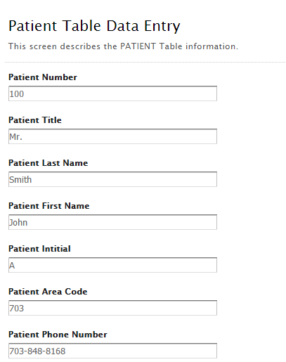

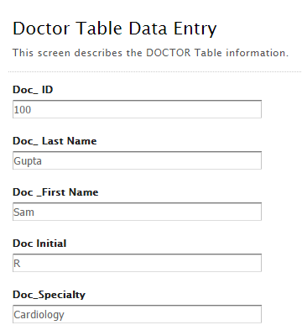Each patient is then assigned to a particular doctor. Each doctor has a doc_id and a specialty that he or she is noted for.

After the doctors consultation a doctor may write one or more prescriptions which may contain one or more drugs. In the backend each drug prescribed is logged in the DRUG database table with its associated drug_code and drug_name and the associated cost of the drug per unit.

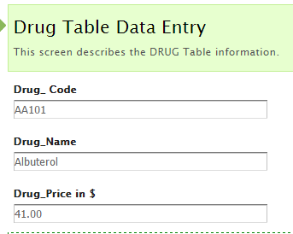

A doctor may write one or more prescriptions which may contain one or more drugs. Each prescription is documented in the prescription table with a prescription_id and date its associated doctor id, patient number, drug code prescribed and recommended prescription dosage suggested by the doctor.

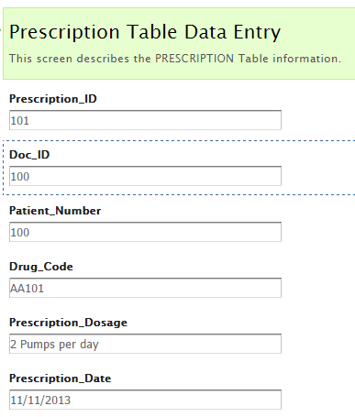

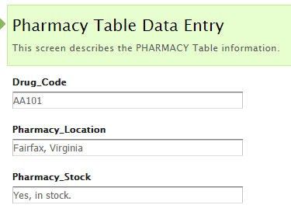

The clinic keeps track of nearby pharmacies that stock the prescribed drugs. Each drug is indexed by drug code and matched to a pharmacy in Fairfax, McLean or Springfield locations in Virginia. Each drug is described as being in or out of stock.